Internship Test

Design and implement a web application for the following scenario:

An IT company needs a way to manage their employees. Every employee that is introduced inside the system has the following information: Social Security Number (CNP), Name, Email, Department, Job Title. Each employee needs to have one team leader from the same department.

When defining a new department, the first employee added to this department by default is lead by the CEO. The CEO is the only employee that can lead employees from different departments.

Taking all of this into account, we define the following functionalities:

1. **Adding a new employee:**

After recruiting a new person, the system needs the following information to define the new employee:

* **Social Security Number (CNP)**
* **Name**
* **Email**
* **Department**
* Job Title (optional)
* **His team leader**
* The team that he will lead (optional)

The new employee can lead only employees from the same department. If an employee is hierarchically defined “between” a leader and his subordinate, the old hierarchical links will be automatically deleted.

The application validates all fields and notifies the user in case of an inconsistency in the data that has been inputted.

**Examples:**

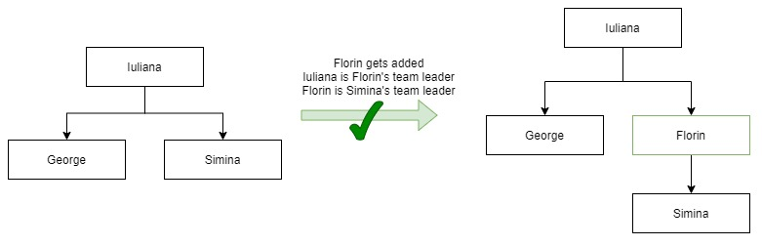

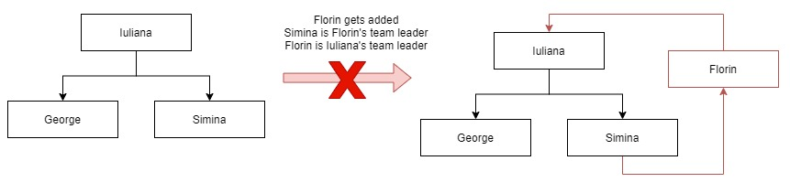

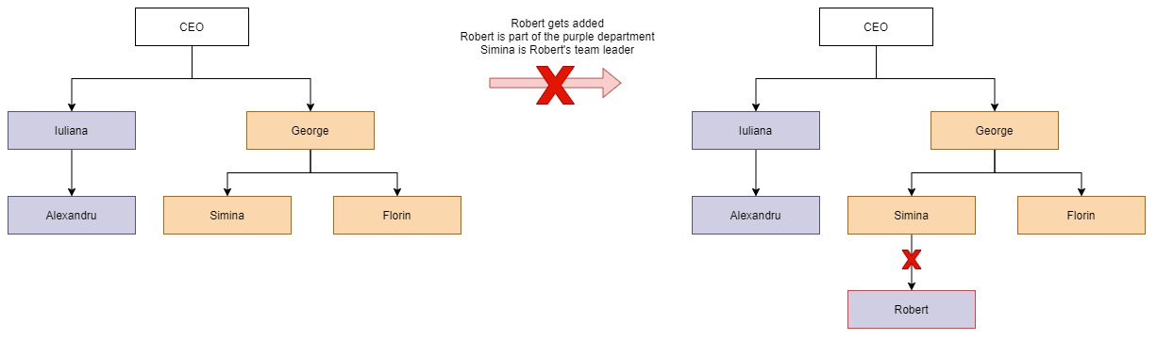

1. **Updating an existing employee:**

The application allows the user to update an existing employee. All fields can be changed, **except for the social security number (cnp)**.

The same validations apply as when adding a new employee.

1. **Deleting an employee:**

When deleting an employee, the hierarchical links between his leader and his subordinates are automatically created. No employees are left without a team leader.

**Example:**

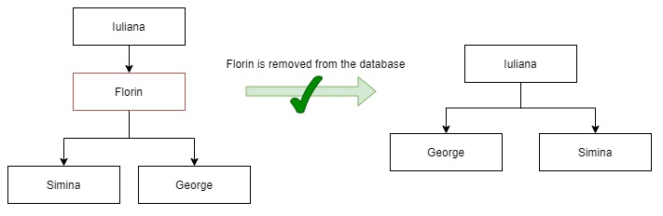

1. **Displaying all the employees:**

The application can display all the employees in the form of a flowchart. (you can style the flowchart as you see fit)

1. **Reports (optional):** 
   * Display the employee/s that are part of the longest hierarchical chain
   * Display all the leaders of a department
   * Display all the employees of a department that are not leaders

**Technical requirements:**

Backend: .NET

Frontend: any framework of your choice

Database: any type of database (including simple files)

Include a schema (diagram) of your database. If you opted for files send an UML diagram. If you’re not using files send creation scripts for your database.

**Please send your work even if it’s incomplete.**

**Good luck**

🏁